Watch Everything You Love with Premium IPTV Services – Here’s How

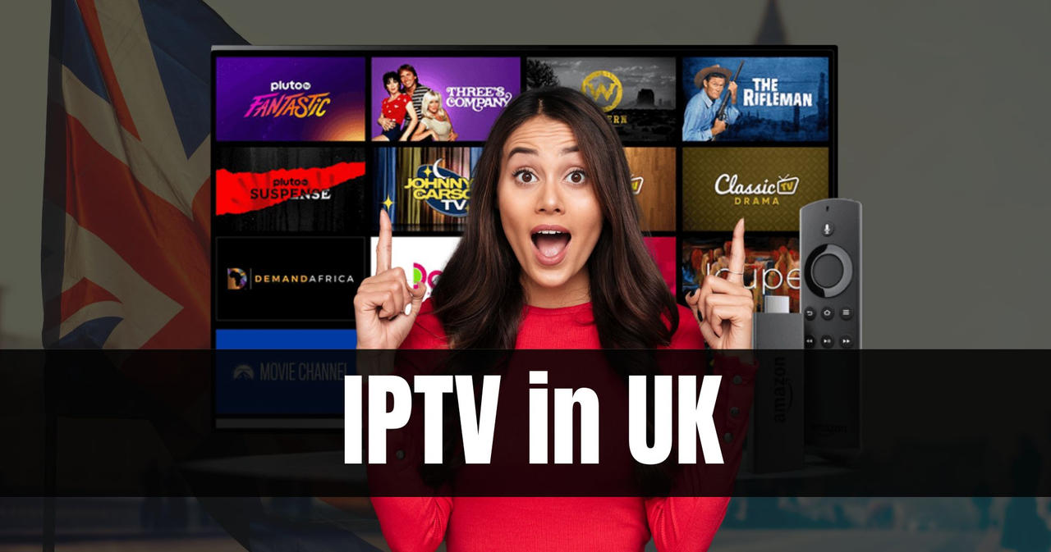

In the age of digital content consumption, traditional television is rapidly being replaced by more flexible and cost-effective alternatives. One of the most prominent options is IPTV (Internet Protocol Television), which provides users with a rich, unlimited entertainment experience that traditional cable or satellite TV cannot match. Whether you're a sports fan, a movie lover, or a series binge-watcher, premium IPTV subscriptions offer a wealth of content that suits every preference. If you're looking to elevate your viewing experience, investing in the best premium IPTV service today could be the key to unlocking unlimited entertainment.

**What Is IPTV and Why Is It Gaining Popularity?**

IPTV stands for Internet Protocol Television. Unlike [Deutschland IPTV](https://rapidiptv.store/) traditional television services that rely on satellite or cable signals, IPTV uses your internet connection to stream TV shows, movies, sports events, and more. The ability to access content from any device with internet connectivity has contributed to the rapid rise of IPTV services worldwide.

The popularity of IPTV has soared because it offers numerous benefits over traditional television. It provides a more flexible, customizable, and cost-efficient solution for viewers who prefer streaming their favorite shows and channels on-demand. With a high-quality IPTV subscription, you gain access to an expansive library of content that can be streamed live or on-demand, anytime and anywhere.

**Why Choose Premium IPTV Services?**

While there are free IPTV services available, they often come with limitations, such as a lack of content variety, poor picture quality, and interruptions from advertisements. Premium IPTV services, on the other hand, offer a higher standard of entertainment with features that elevate your viewing experience. Here are some compelling reasons why you should opt for a premium IPTV subscription:

**1. Wide Range of Channels and Content**

Premium IPTV subscriptions give you access to a vast library of channels, including local and international broadcasts. Whether you’re interested in news, sports, movies, music, or niche genres, a premium IPTV provider will have it all. Popular channels such as ESPN, HBO, Netflix, and BBC are typically included in premium packages, ensuring that you never miss out on your favorite programs.

Furthermore, the best IPTV services regularly update their channel lineup to keep you in the loop with the latest entertainment trends. You'll find everything from exclusive sports events to international TV shows, documentaries, and premium films. Whether you're watching live events, binge-watching series, or catching up on the latest movies, premium IPTV services offer unparalleled access to global content.

**2. High-Quality Streaming Experience**

One of the most significant advantages of premium IPTV services is the quality of the streams. Unlike free IPTV services, which often provide low-resolution streams, premium providers offer content in HD, 4K, and even 8K resolutions. This means you can enjoy your favorite shows and movies with crisp visuals and crystal-clear audio, giving you a cinema-like experience from the comfort of your home.

Many premium IPTV services also offer adaptive streaming, which automatically adjusts the video quality based on your internet speed. Whether you have a high-speed connection or a slower one, premium IPTV services will optimize your viewing experience without buffering or interruptions.

**3. Flexibility and Accessibility**

With IPTV, the world of entertainment is at your fingertips. Premium IPTV subscriptions are designed to be flexible and accessible across multiple devices, allowing you to watch content on your television, smartphone, tablet, laptop, or even smart devices such as Amazon Fire Stick or Roku. This multi-device accessibility ensures that you can enjoy your favorite channels and programs wherever you are, whether at home or on the go.

Moreover, many premium IPTV services come with an electronic program guide (EPG), which allows you to browse through available shows, channels, and events. This makes it easy to plan your viewing schedule and never miss a show.

**4. Cost-Effective Entertainment**

In comparison to traditional cable or satellite TV subscriptions, premium IPTV services are often more affordable. Cable and satellite TV providers charge hefty fees for limited channel packages, while IPTV subscriptions typically offer more affordable, all-inclusive packages with a variety of channels and features. By subscribing to IPTV, you can save a significant amount on your entertainment expenses without sacrificing content quality or variety.

Furthermore, premium IPTV providers often offer flexible pricing plans to suit different budgets, ensuring you get the best value for your money. Whether you’re looking for basic access or a more comprehensive package with all the premium channels, there’s an IPTV plan that fits your needs.

**5. Customizable Packages**

One of the standout features of premium IPTV services is the ability to customize your subscription. Unlike traditional TV services where you are locked into predefined channel bundles, IPTV providers let you choose only the channels and content you want to pay for. This flexibility allows you to create a personalized entertainment package tailored to your preferences.

Premium IPTV providers also offer add-ons for additional content such as exclusive sports events, international programming, or pay-per-view movies. You can build a subscription package that gives you exactly what you want without paying for unnecessary channels or content.

**Choosing the Best Premium IPTV Service**

Not all IPTV services are created equal, and selecting the right provider can be a daunting task. To ensure you get the best IPTV experience, it's important to consider the following factors:

**1. Channel Lineup**

The most important factor when choosing an IPTV service is the channel selection. The best premium IPTV services offer a comprehensive range of live TV channels, covering everything from sports and entertainment to news and documentaries. Look for providers that include popular channels and networks that cater to your interests, whether you're into sports, movies, or international content.

**2. Content Quality**

Content quality is another crucial aspect to consider. Premium IPTV services should offer HD, 4K, and even 8K content, ensuring a high-quality viewing experience. It's important to test the service for streaming quality, including resolution, buffering, and overall performance. A good IPTV service will provide smooth, uninterrupted streams with excellent picture and sound quality.

**3. Device Compatibility**

Ensure that the IPTV service is compatible with your devices. Premium IPTV services support a wide range of devices, including smart TVs, computers, tablets, smartphones, and streaming devices like Roku and Amazon Fire Stick. A versatile service that works on all your devices provides the flexibility to watch content wherever you are.

**4. Customer Support**

Good customer support is essential when using any IPTV service. Look for a provider that offers reliable support options, such as live chat, email, or phone assistance. Responsive and helpful customer service ensures that any technical issues or questions are resolved quickly, allowing you to enjoy your IPTV service without disruptions.

**5. Price and Subscription Plans**

Finally, consider the price of the IPTV service and the available subscription plans. The best premium IPTV providers offer flexible pricing based on your needs and budget. Some providers offer tiered packages with varying levels of content, while others offer all-inclusive plans. Be sure to compare pricing and features to find a plan that suits your viewing habits.

**Conclusion**

Premium IPTV services are revolutionizing the way we consume television and entertainment content. With a wide range of channels, high-quality streaming, flexible subscription options, and competitive pricing, they provide a superior viewing experience compared to traditional TV services. By choosing the right premium IPTV provider, you can unlock a world of endless entertainment that caters to all your viewing preferences. Embrace the future of television today by upgrading to a premium IPTV service, and enjoy limitless access to the best content available.